



VO PROPOSAL

**{{image_placeholder}}**

**PREPARED FOR:**

**{{Sitename}}**

**{{Address}},**

**{{City}}, {{Postcode}}**

**DATE: {{date}}**

**Quote Ref: {{Quote}}**



## WHAT WE DO...

Electrical Mechanical & Cooling Limited are an engineering company who have been in business for over 20 years. We are an expert M&E service provider and independent supplier of critical power and cooling solutions for critical, industrial and commercial operations.

Our independent status means that we are always working to find and install the best technology for your specific project and site needs

We pride ourselves on our craftsmanship, technical expertise, compliance knowledge and project delivery.

We are always working to keep your site protected, optimised and energy efficient.

Our sister company Emissis deliver a powerful suite of globally patented, innovative energy reduction solutions that save their clients money by lowering energy bills whilst reducing their carbon emissions.

Core technologies include Voltage Optimisation (VO) & Stabilisation, Commercial Energy storage, EV charging and PV + Battery and Coolnomix. EMC deliver, via our in house engineering team an energy efficient end to end solution from Site Survey

- ROI analysis & payback guarantees - Installation - Monitoring and Verification.

**WE WORK WITH...**

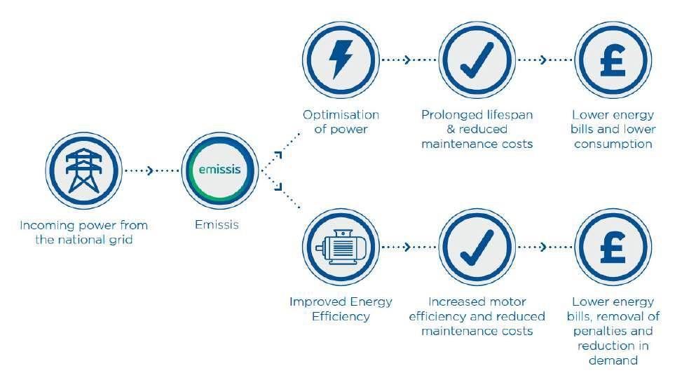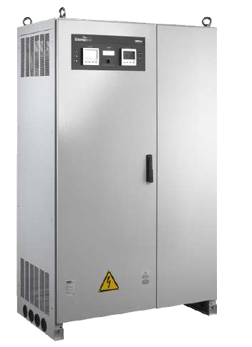

## HOW DOES VO WORK

The National Grid delivers, on average, 242 volts to all UK users.

With voltage optimised, electrical equipment works at optimum cost efficiency at 220 volts. All supply above 220v is waste.

Through Ohm’s law, optimising voltage on any supply produces instant kWh savings of up to 19%, which will give an instant reduction in electricity bills and carbon footprint. In addition, and as confirmed by the UK’s wiring regulations (BS7671), any electrical equipment required to work at 242v, will suffer a reduced working life by up to 46%.



**Quotation based on Meter Reading**

|  |  |
| --- | --- |
| Annual Electrical Consumption (kWh): | {{Annual Consumption kWh}} |
| Annual Electrical Spend: | £{{Annual spend}} |
| Day & Night Rate Supply Price: | £{{tariff}} |
| VO unit size: | {{VO Size}}a |

**Equipment Cost (inc Installation & Initial Monitoring)**

**£{{Capital Cost}} + VAT**

**Monitoring & Verification Annual Cost: £200 per Connected Device**

|  |  |  |  |
| --- | --- | --- | --- |
| **{{per}} % Savings** | **1 Year** | **5 Years** | **10 Years** |
| **Consumption Reduction** | {{kWh}} kWh | {{kWh5}} kWh | {{kWh10}} kWh |
| **Carbon Savings** | {{co21}} Tons Co2 | {{co25}} Tons Co2 | {{co210}} Tons Co2 |
| **Electricity Cost Reduction** | £{{cost1}} | £{{cost5}} | £{{cost10}} |
| **Payback** | **{{ROI Months}} Months** | | |

**1 Year**

{{kWh_1}} kWh

**Consumption Reduction**

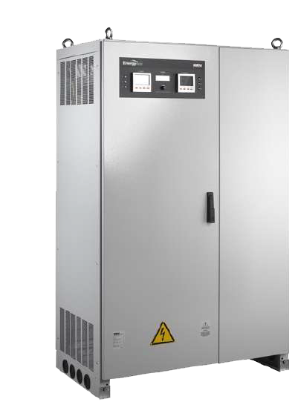

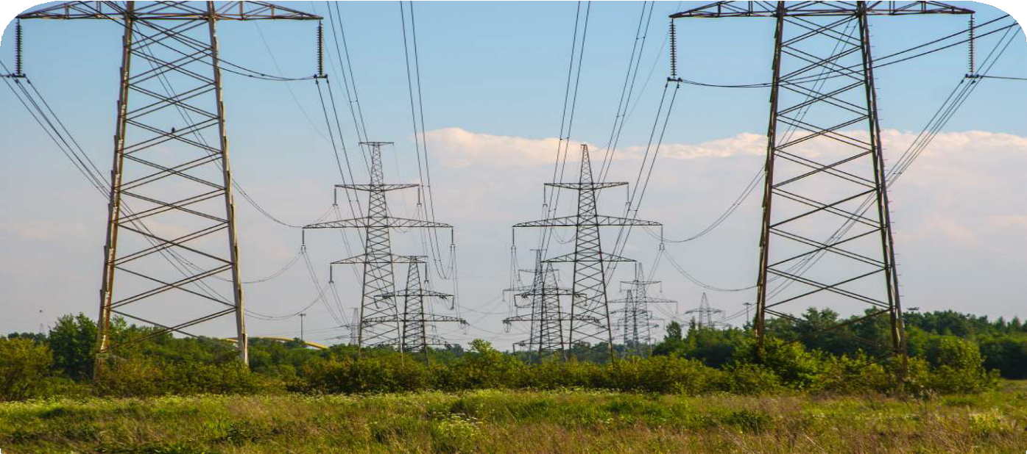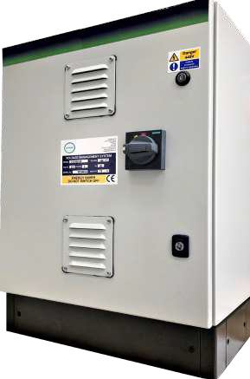

|  |
| --- |
| **Options:** |
| Power / Energy Metering & Remote Monitoring |
| Voltage Stabilisation (±0.5% or ±1% Accuracy (options available) |
| Balanced or Independent Phase Balancing |
| Under Voltage Protection |
| By-pass switch |
| Over Temperature Protection |
| Harmonic Filtration |
| Surge & Lighting Protection |
| Single Phase Options |
| Environmental – Up to 60 Deg C (extreme options available) |

### Technical Characteristics

#### Dynamically Designed Voltage Optimisation & Energy Saving Technology

|  |
| --- |
| **Features** |
| Ultra Low Loss Transformer Technology 99.9% Efficiency |
| Selectable Voltage Output (-10v, -15v, -20v, -25v) |
| Minimum 5 years Warrantyvoltage optimiser uk |
| Very Low Maintenance |
| Wide Range of Models to Suit All Environments |
| Permanent Power Ratings |
| Efficient Toroidal Transformer Design |
| Overcurrent Protection – MCCB |
| Integrated Isolation |
| High Overload Capability |
| Patented Design |
| Range 1kVA to 8,000kVA |
| Natural Ventilation |
| 15 Years Warranty |
| BSEN60831 (IEC831 & IEC70/70), BSEN60439, BSEN60204 |
| ISO 9001 Quality Assurance |

|  |
| --- |
| **Benefits:** |
| Reduction in Energy Bills |
| Reduction on Carbon Emissions |
| Reduction in Whole Site Maintenance Cost |
| Protection of Appliances |

1. **EMISSIS ENERGY & CARBON MONITORING PLATFORM**

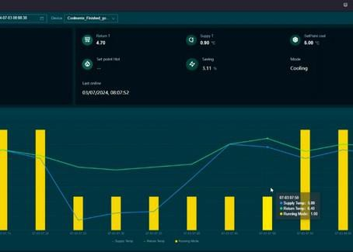

Our voltage optimisation maintenance service package is complimentary for the initial three years following purchase and consists of one annual inspection at 30 months.

### Real Time Monitoring:

* + Remote monitoring via cloud based platform EnOS - the World’s most comprehensive decarbonisation system.
  + EnOS platform connects operational technology with cloud intelligence for real-time energy data and carbon monitoring.
    - The system integrates data from all client hardware and software systems into one comprehensive solution for real-time visibility and control of energy usage and carbon

emissions.

* + Serves 500+ customers, 220M connected devices, 568 GW of managed energy assets.
    - Scalable, managing millions of IoT devices with 99.95% availability.
      * Deployable in Azure, AWS, Google Public Cloud, or on-premise.
      * Supports IPMVP standard-based energy monitoring, renewable management, and carbon accounting.
      * Connects with 250+ protocols and integrates with other cloud systems using adaptable Component Building Blocks.

**Emissis Manufacturers Equipment Warranty**

Emissis stands behind the quality and durability of our Voltage Optimisation equipment. We provide a warranty guaranteeing that our equipment will consistently deliver the promised voltage reduction and operate flawlessly for a minimum of 15 years from the installation date.

With our commitment to customer satisfaction, you can trust in the long-lasting performance and reliability of our cutting-edge technology.

We have meticulously designed and tested each component to ensure that it withstands the test of time. Choose our Voltage Optimisation equipment and enjoy the benefits of sustainable energy management for years to come.

1**5 Years Manufacturers Warranty**

**Made in the UK Finance Options Available**





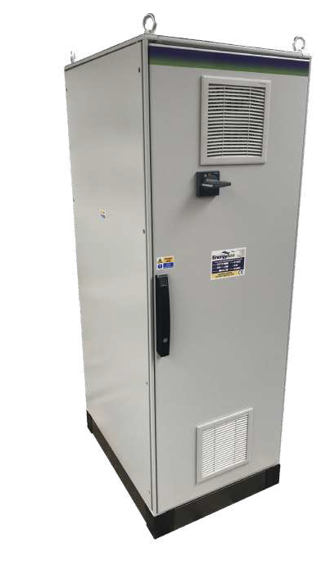

# Summary

|  |  |
| --- | --- |
| Total Annual kWh savings: | {{kWh}} |
| Total Annual Financial Savings: | £ {{cost1}} |
| Total Capital Cost: | £ {{Capital Cost}} |
| ROI: | {{ROI Months}} Months |

### Contact Emissis

##### PREPARED BY:

**Tony Frampton**

**Tel: +44 (0) 7907 642464**

**Email:**

[**tony.frampton@emissis.com**](mailto:tony.frampton@emissis.com)

##### OFFICE:

**Tel: +44 (0)1642 049024**

**Email:** [**enquiries@emissis.com**](mailto:enquiries@emissis.com)

##### ADDRESS:

**Emissis, 2 Ellerbeck Court, Stokesley, TS9 5PT**